Evaluating Neural Network Performance in Image Recognition: The Impact of Training Environments and Optimization Strategies

Name: Orla Kavanagh
Student ID: sba24195
Course Title: MSc in Data Analytics

Abstract— This paper examines how well Convolutional Neural Networks (CNNs) perform when processing large image datasets. It focuses on three key areas: the complexity of the network design, the type of training environment (using one computer versus using several), and the strategies used to enhance network performance. The study involved testing different CNN models with two image datasets, Fashion MNIST and CIFAR-10. The models tested include a basic CNN, VGG16 (similar to AlexNet) and ResNet50.
In this paper, two popular machine learning frameworks, PyTorch and TensorFlow, were used to train the models. Training was carried out on a single computer and also on a single node Virtual Machine (VM), but the setup also included distributed training using PyTorch’s DataParallel and TensorFlow’s tf.distribute.MirroredStrategy. Distributed training didn’t show major benefits for simpler models or datasets, mainly because the researcher was limited to a single-node environment. As a result, the full advantages of distributed training couldn’t be demonstrated here, but it was still explored as a useful structure for potentially scaling to multiple machines in future work. That said, even without multiple GPUs, there were still benefits, particularly with complex models like ResNet50 (He et al., 2016), where accuracy and learning speed improved noticeably.
The study also looked into various optimization techniques such as batch normalization (Ioffe and Szegedy, 2015), different types of activation functions, and adaptive optimizers (Kingma and Ba, 2017). These techniques influenced how stable the training process was and how well the models performed overall. This research underscores the importance of selecting the appropriate network architecture, considering the complexity of the dataset, and choosing effective training strategies when scaling neural networks for analyzing large datasets (Najafabadi et al., 2015).

Introduction
In recent times, the growth of big data has been very fast, and tools for analyzing data have advanced significantly. Together, these changes are revolutionizing how we recognize and classify images. Convolutional Neural Networks, or CNNs, are key elements in deep learning. They are very successful at processing complex, high dimensional, image data, especially when used on a large scale (Krizhevsky, Sutskever and Hinton, 2017). Yet, as the size and complexity of data grows, we need not only strong models but also efficient training setups that use distributed systems and GPU acceleration (Abadi et al., 2016; Dean et al., 2012).
This study evaluates the performance of different CNN designs, from basic models to advanced ones like ResNet50 and AlexNet, in both single-node and distributed training setups. The research uses Fashion MNIST and CIFAR-10 datasets to represent small- and mid-sized image classification tasks (Xiao, Rasul and Vollgraf, 2017). It explores how the choice of training setups, optimization strategies (such as optimizers, activation functions, and batch normalization), and design decisions affect the model's accuracy and efficiency in computation.
The main question being explored is: How effectively do neural networks recognize images? Additionally, what impact do different training setups (single node versus distributed) and optimization methods have on improving both efficiency and accuracy?
By implementing and testing these models with PyTorch and TensorFlow across various environments, this study provides a practical evaluation of distributed deep learning in big data scenarios. The paper follows with sections on reviewing related literature, describing the methodology used, presenting the results, discussing the findings, noting any limitations, and suggesting future research directions.

Literature Review

Introduction to CNNs and Big Data
Convolutional Neural Networks (CNNs) have shown remarkable success in image classification, particularly when processing large-scale, high-dimensional datasets characteristic of big data (Chen et al., 2021, Najafabadi et al. 2015). Traditional methods for understanding images required people to manually pick out features, but Convolutional Neural Networks (CNNs) do this automatically. CNNs can take raw image data, find important features on their own, and then determine what the image shows (Chen et al., 2021, Krizhevsky et al., 2017, Sharma et al., 2018). This makes CNNs very important for handling large amounts of visual information, which helps in big data analysis (Najafabadi et al., 2015).
Big improvements in how CNNs are built, like AlexNet and ResNet, have changed how images are sorted in huge datasets like ImageNet. AlexNet, developed by Krizhevsky et al. in 2012, showed that automatically learned features could be better than manually chosen ones. This was a significant step for using deep learning with big data. AlexNet consists of eight layers: five handle complex image processing tasks, and three make the final decisions about the image classification. It also uses techniques like ReLU activation functions and dropout methods to manage complexity, data augmentation to increase the dataset's variability, and overlapping pooling to avoid overfitting the model to the training data. These techniques allow CNNs to scale effectively to large, complex datasets, aligning with the volume and variety of big data.
ResNet, proposed by He et al. (2015), further advanced CNNs by addressing the “degradation” problem, where increasing network depth does not always improve performance. By introducing residual learning through shortcut connections, ResNet facilitated training of deeper networks without severe overfitting, optimizing the stochastic gradient descent (SGD) process. These improvements have enabled CNNs to handle the complexity and high-dimensionality typical of big data environments.

The Role of CNNs in Big Data Analytics
Convolutional Neural Networks, or CNNs, are crucial for handling big data. They help with processing and analyzing large datasets. However, CNNs need strong computer power to work effectively. Experts like Krizhevsky, Sutskever, and Hinton explain that CNNs use a technique called weight-sharing to manage big data. But training them on a single CPU computer doesn't work well for large data.
Using GPUs, which are fast processors, and distributed computing, which means using many computers together, has made CNNs much more efficient. This allows CNNs to be applied to large, real-world datasets, as mentioned by Shvachko and others. In computer vision tasks, which involve identifying objects in pictures, models like VGG and ResNet are often used. These models have been trained on large datasets such as ImageNet. By fine-tuning them, they can be adapted for specific tasks, making the most of the available large, labeled data. However, scaling these techniques for truly massive datasets often requires the use of distributed training, a critical strategy in big data analytics.

Big Data Datasets for CNNs
To train and evaluate CNNs (Convolutional Neural Networks) for big data tasks properly, large, varied, and labeled datasets are necessary. These datasets allow researchers to compare CNN performance across different image types. Some important datasets include ImageNet, CIFAR-10, CIFAR-100, and Fashion-MNIST (Chen et al., 2021). It is important for Big Datasets to be stored where multiple nodes can access them. The Hadoop Distributed File System has proved extremely powerful in this respect. (Shvachko, K. et al. 2010)
ImageNet is a very large dataset with more than 1.5 million images, each labeled into one of 20,000 categories. It is often used as a standard for the ImageNet Large Scale Visual Recognition Challenge (ILSVRC). Krizhevsky et al. (2017) demonstrated the effectiveness of CNNs with big data by achieving a 15.3% top 5 error rate with a model known as AlexNet, showcasing CNNs' power in recognizing images.
CIFAR-10 and CIFAR-100 are older datasets containing a total of 60,000 images. However, some argue these datasets are not large enough to reflect the complexity of today's big data requirements (Krizhevsky et al., 2017). They are useful for initial testing and development but may not fully capture the vastness and diversity of current big data.
Fashion-MNIST is an update to the MNIST dataset and includes 70,000 images. It is designed to provide a tougher challenge for CNNs, testing their ability to handle more complex image recognition tasks. While beneficial for rapid testing, it is not representative of the vast, dynamic datasets typically found in big data applications.

Single Node vs. Distributed Training in Big Data
Training CNNs on large, high-resolution datasets is computationally intensive, especially in big data contexts. Single-node training is constrained by memory limits and extended training times. In 2017, Krizhevsky, Sutskever, and Hinton needed 5 to 6 days to train a model called AlexNet. They used two NVIDIA GTX 580 GPUs for this. This slow process shows why it's important to use distributed training when dealing with large data sets. Tools like TensorFlow and DistBelief help make this easier. These tools let training happen on thousands of computers at the same time by using data parallelism and model parallelism. Data parallelism means spreading the data across different computers, while model parallelism means splitting the model's parts across different computers. This approach makes training faster and more efficient for big data projects. However, synchronization issues and communication overhead can hinder performance in distributed training, particularly with the massive datasets typical in big data (Sergeev and Balso, 2018).
While distributed training can mitigate the computational strain of big data, it introduces challenges like network latency, parameter synchronization, and the risk of inconsistent model updates during asynchronous training. Nonetheless, distributed training is pivotal for scaling CNNs to handle the volume, variety, and velocity of big data.(Dean et al., 2012, Sergeev and Balso, 2018)

Optimization and Performance in Big Data
Efficient optimization methods are very important for training Convolutional Neural Networks (CNNs) on large datasets. Common methods include Stochastic Gradient Descent (SGD) and versions like Adam and AdaGrad. These methods are chosen because they can handle large data sizes and complex challenges.
Adam is often used because it changes learning rates automatically and doesn't need much memory, which is helpful for big data tasks. Batch normalization makes training more stable and often means dropout may not be necessary in big projects. Dropout is used to prevent overfitting by randomly turning off some neurons, and it is effective with large datasets. Advanced techniques like label smoothing, data augmentation, and early stopping are essential for optimizing CNNs on complex, high-dimensional big data.(Sharma et al., 2018) Distributed training further leverages these techniques to improve model convergence across vast, parallelized datasets, a necessity for efficient big data analytics.
CNNs are very good at working with large amounts of image data. However, their success largely relies on the computing methods used. To overcome the challenges that come with big data and ensure the training of neural networks is scalable, accurate, and efficient, it's important to use distributed training and advanced techniques for optimization. These strategies help the networks handle more data without losing performance or accuracy.

Methodology
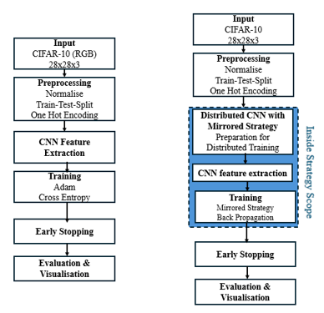
This study explores the performance of various Convolutional Neural Network (CNN) architectures for image recognition tasks, using two datasets, Fashion MNIST and CIFAR-10, as benchmarks for increasing complexity. It further evaluates how training environments (single node vs. distributed) and optimization strategies affect efficiency, training time, and accuracy. Experiments were conducted using PyTorch and TensorFlow in CPU-bound environments. Although multi-GPU execution was not available, distributed training was implemented in code to simulate GPU-enabled setups and explore the structure and feasibility of scaling to more powerful hardware

Initial Hardware and Dataset Constraints
The original intention was to train models on the ImageNet dataset; however, due to computational limitations of the available single-node CPU-based machine, this was not feasible. As a result, initial experiments used CIFAR-100 to simulate a large-scale training scenario. A publicly available CNN implementation was adapted, and runtime comparisons highlighted the stark difference in computational load between GPU and CPU environments: the author’s model trained on GPU P100 in 36 minutes, while the same model took over 24 hours to complete on a single CPU node.
This comparison underscored the necessity of optimizing for hardware constraints and influenced the decision to adopt smaller, more manageable datasets (Fashion MNIST and CIFAR-10) for subsequent experiments.

Framework and Enviornments
Two primary machine learning frameworks were used in this study: PyTorch and TensorFlow.
PyTorch was initially tested in a CPU-bound virtual machine (OracleBox), incorporating torch.nn.DataParallel to simulate distributed training. While this setup did not support true parallelism across GPUs, it enabled experimentation with the structure and behavior of distributed training strategies.
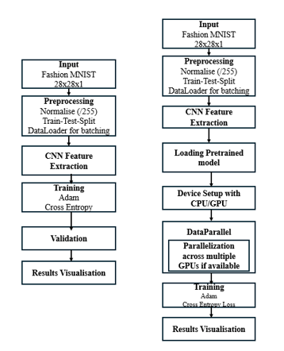
Further experiments were conducted using TensorFlow with Keras, a high-level API, on a more capable single-node Windows machine with increased RAM and access to CUDA acceleration. TensorFlow was selected for its strong reputation in scalable deep learning applications and its streamlined deployment of distributed models. Developed by researchers at Google, TensorFlow offers flexibility for both prototyping and production-level training (Pang, Nijkamp, & Wu, 2019). When paired with Keras, the framework allows for intuitive model development through a modular, layered approach, reducing complexity and improving reproducibility in model definition.
TensorFlow’s integration with CUDA and cuDNN, along with the tf.distribute.MirroredStrategy API, made it particularly suitable for simulating GPU-based training, even within limited hardware contexts.

Datasets
Fashion MNIST (Xiao, Rasul and Vollgraf, 2017): 70,000 grayscale images across 10 clothing categories. Chosen for its simplicity and popularity in model prototyping.
CIFAR-10: 60,000 32×32 RGB images across 10 classes. Selected as a step toward simulating big data through added image complexity and color dimensions.
Fashion MNIST was loaded through DataLoader, sampled (due to hardware limitations with large file), converted and saved to csv file to be loaded onto Hadoop Distributed file System (HDFS). These were then called into the notebook and processed. This was to simulate the distributed system only. Subsequent experiments were done on the original DataLoader dataset as this was larger and would produce better results.

Model Architechtures

Basic CNN (CNNNet)
This three-layer CNN served as a foundational model to benchmark performance on both Fashion MNIST and CIFAR-10. The design is created to catch image details step by step, without using too much computer power. This makes it good for testing in areas with fewer resources. It uses ReLU activations and MaxPooling, which help find important changes in images and make the data easier to handle. Dropout is included to stop the model from focusing too much on one small set of data, which is important when the dataset isn't large. This setup is like a starting point that helps us compare with more advanced models. It lets us see how adding more layers and changing how we train the model can change the outcomes. A visualization of this architecture can be seen in “Fig. 3” and “Fig. 4”.
This model was tested under both distributed and non-distributed environments using batch sizes of 64 (Fashion MNIST) and 128 (CIFAR-10).

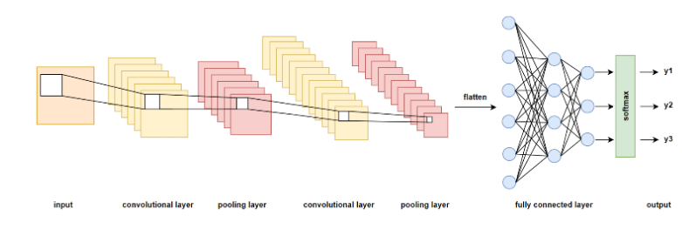
AlexNet proxy (VGG16)
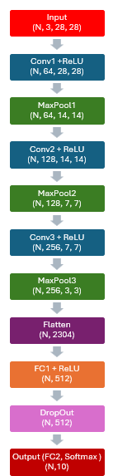
The AlexNet proxy is based on the VGG16 architecture but with simplified fully connected layers. AlexNet was one of the earliest deep CNNs to gain attention for image classification after outperforming traditional methods on the ImageNet dataset (Krizhevsky, Sutskever, and Hinton, 2017). It was included in this study to evaluate how classical CNN architectures, designed for high-resolution data, perform on lower-resolution tasks like CIFAR-10. The model's performance was also tested under various training configurations to assess its adaptability and sensitivity to optimization strategies. See “Fig. 6” for the key features of this model

ResNet50
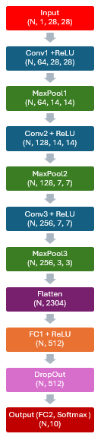
ResNet50 was selected to represent deep architectures designed to overcome the vanishing gradient problem through residual connections (He et al., 2016). These skip connections allow gradients to pass directly through identity mappings, enabling the network to maintain performance even at greater depths. ResNet50 has been widely adopted in large-scale image recognition tasks and is particularly well-suited for distributed training due to its high parameter count and depth. It was included to explore how deeper models scale under distributed setups and whether structural advantages translate into measurable performance gains in more complex datasets. See “Fig. 6”.

Optimization Testing with CNNNet
This flexible architecture was developed specifically to evaluate the individual impact of optimization techniques such as:
Batch normalization (Ioffe and Szegedy, 2015).
Various activation functions (ReLU, Sigmoid, Tanh, Leaky ReLU),
Data augmentation and dropout,
And optimizer selection (Adam vs. SGD; Kingma and Ba, 2017).
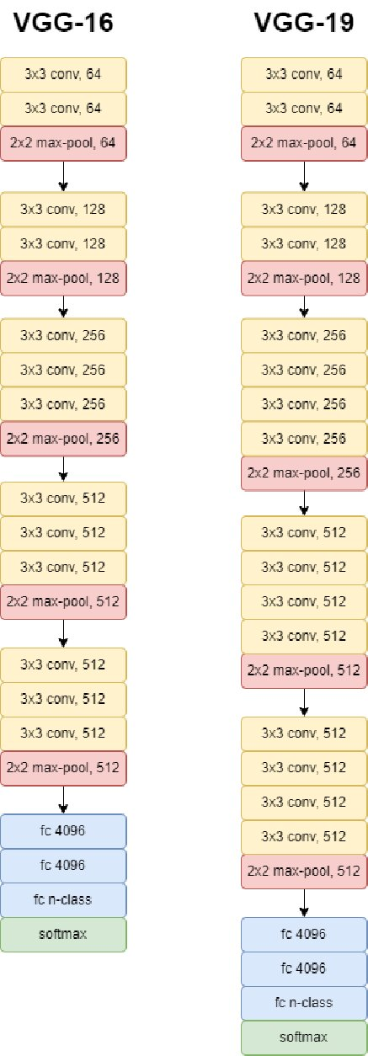
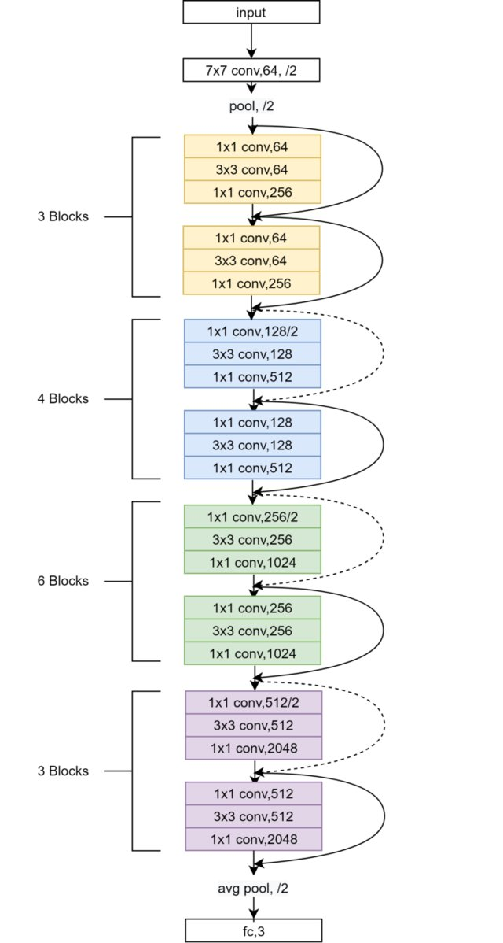
The modularity allowed for isolated testing of each feature while keeping other network parameters constant. This model was essential for conducting comparative analysis and identifying which techniques contributed most to accuracy and training stability, particularly on the CIFAR-10 dataset.

Distributed Training Implementation
Distributed training was implemented using:
PyTorch: torch.nn.DataParallel, tested in a single-node environment to simulate multi-device parallelism.
TensorFlow: tf.distribute.MirroredStrategy, enabling data parallelism across available GPUs.
Despite hardware constraints (e.g., no access to multi-GPU clusters), the experiments established the infrastructure for scalable distributed training.
In this environment, TensorFlow consistently outperformed PyTorch in terms of runtime. While no GPU acceleration was available in either setup, the performance difference may be attributed to TensorFlow’s more efficient memory management and internal optimizations (Pang, Nijkamp & Wu, 2019). TensorFlow’s design for seamless GPU integration via CUDA and cuDNN may also contribute to its advantages in more capable hardware scenarios.

Applying to CIFAR-10 and Further Testing
After confirming stable model behavior on Fashion MNIST, experiments shifted to CIFAR-10 to simulate increased data complexity (color channels, more variability). The following tests were conducted:
Training CNNNet on CIFAR-10 with and without distributed training
Testing optimizers (SGD vs Adam)
Applying batch normalization
Comparing activation functions (ReLU, Sigmoid, Tanh, Leaky ReLU)
Assessing data augmentation
Each configuration was tested independently to isolate its effect on model performance (accuracy, training time, and validation loss).

Results
This section presents the performance outcomes of the various CNN architectures tested under different training environments and optimization strategies. Key metrics include training time, accuracy, and validation loss across both single-node and distributed configurations, using the Fashion MNIST and CIFAR-10 datasets. See “Table 1” for full summary.

Effects of Training Enviornments on Model Performance

CNNNet on Fashion MNIST
When trained on a single CPU node using PyTorch, CNNNet achieved an accuracy of 0.9248 over 64.53 minutes. Using DataParallel to train in a distributed way took 105 minutes, likely because it uses more computer resources (but possibly due to the VM logging itself out while training). This approach did make the accuracy a little better, reaching 0.9249. On the other hand, using TensorFlow or Keras to train the same model on just one computer took 18.41 minutes, with an accuracy of 0.9217. When trained with MirroredStrategy, it was slightly faster at 14.64 minutes, and the accuracy was almost the same at 0.9215.”Fig. 9”, “Fig. 10”. This suggests that for simple datasets like Fashion MNIST, using a distributed set up for training doesn't really improve accuracy much and only saves a small amount of time when everything works well. Working with a single node will have effected the impact of this, so it would not be sensible to make any judgements based on these results alone. “Fig. 7” and “Fig. 8” compare CNNNet performance in PyTorch with and without DataParallel.)

CNNNet on CIFAR-10

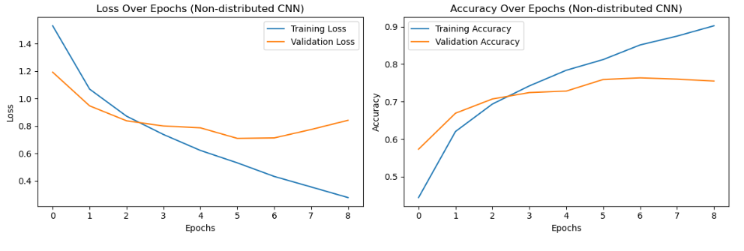
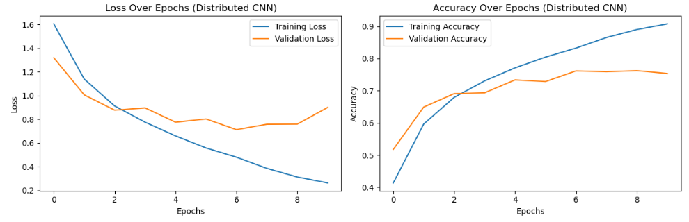
With CIFAR-10, TensorFlow/Keras trained CNNNet in 10.38 minutes (undistributed), achieving an accuracy of 0.9101. The distributed version (using MirroredStrategy) ran in 10.43 minutes and reached 0.9125 accuracy. Again, performance gains were minimal, indicating that CNNNet does not benefit significantly from distribution on smaller-scale datasets, even when complexity increases. “Fig.5” and “Fig. 11” and “Fig.12” show the effects of distributed training on CNNNet with CIFAR-10. Again, this is not showing much impact because of single node environment, not true distributed environment.
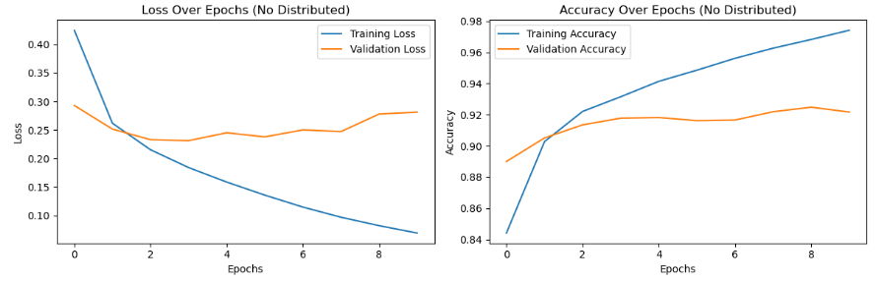
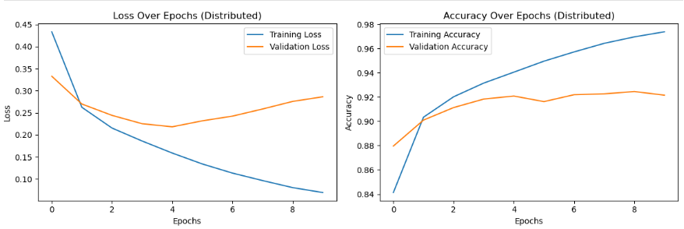
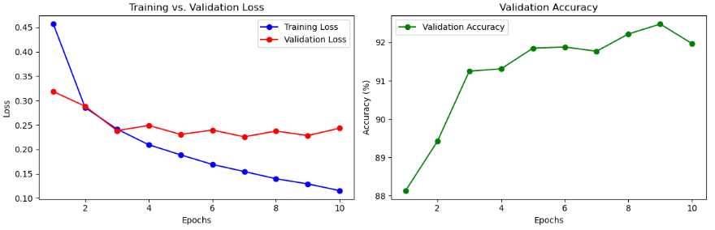
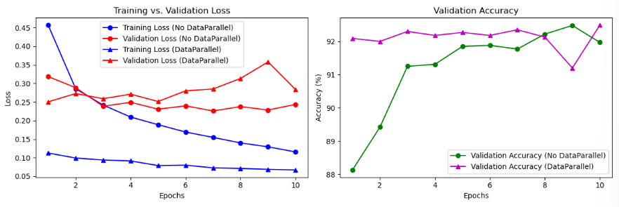

Model Architecture Comparison (CIFAR-10)
To assess generalization and scalability, the following pretrained models were evaluated on the CIFAR-10 dataset: VGG16 (used as an AlexNet proxy) and ResNet50.

VGG16 (AlexNet Proxy) vs. ResNet50
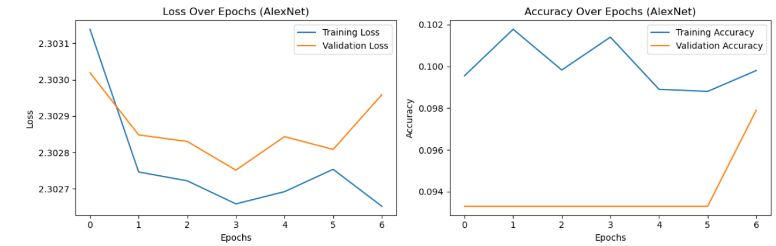
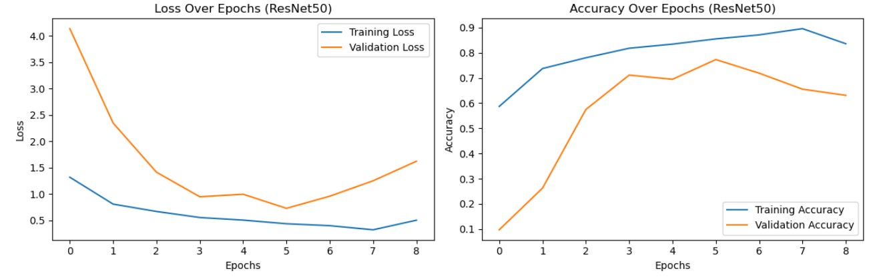
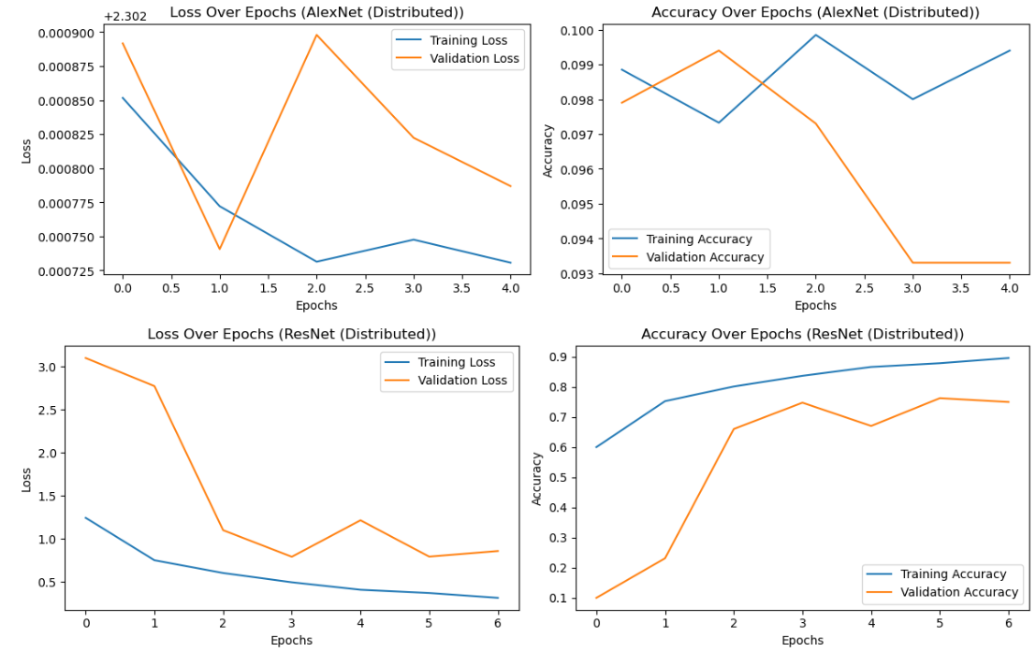
The AlexNet proxy initially performed poorly, achieving only ~0.10 accuracy in both distributed and non-distributed settings. High loss values (~2.3030) indicated the model was not learning effectively. In contrast, ResNet50 demonstrated more stable convergence and superior performance. When trained without distribution, ResNet50 reached an accuracy of 0.8075, while the distributed version achieved 0.9071—a substantial improvement. Validation loss also decreased significantly, from 1.6214 to 0.8581. “Fig. 13”, “Fig. 14”, and “Fig. 15” highlight the disparity in performance between AlexNet and ResNet50.

In terms of runtime, TensorFlow outperformed PyTorch across both models. This difference is likely due to more efficient GPU utilization and memory management in TensorFlow, as well as its integration with CUDA and cuDNN, which contributed to smoother execution and faster convergence (Pang, Nijkamp & Wu, 2019).

Improving VGG16 (AlexNet Proxy)
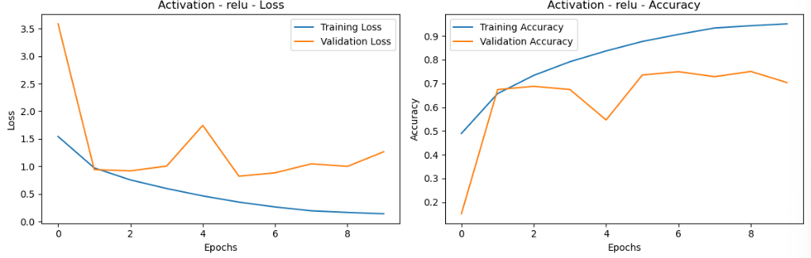
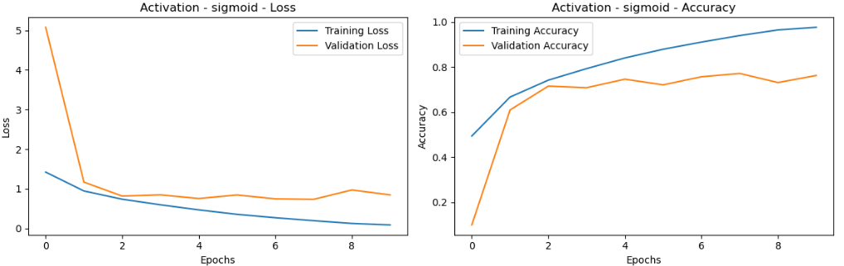
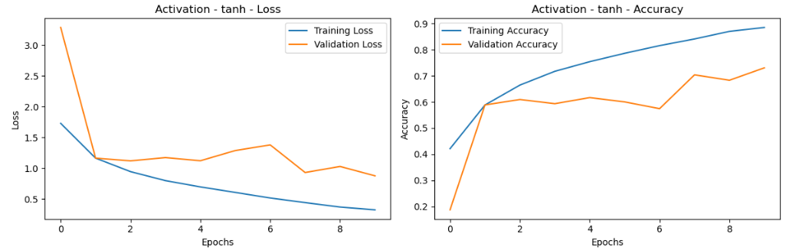
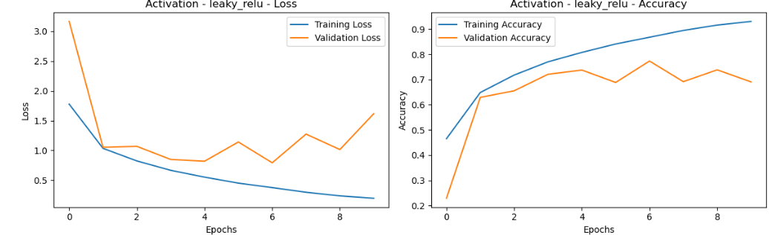
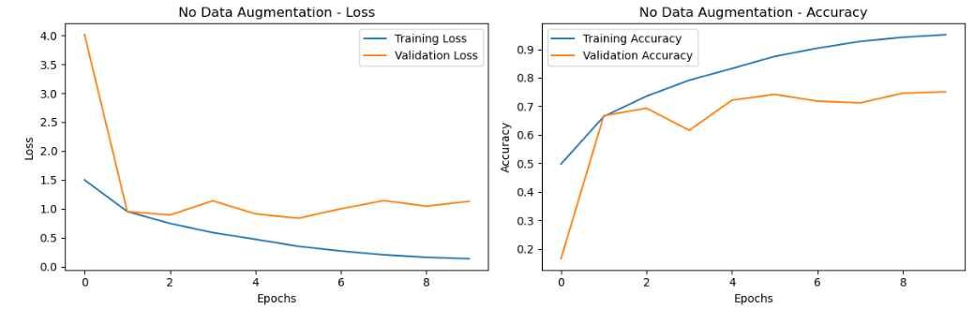
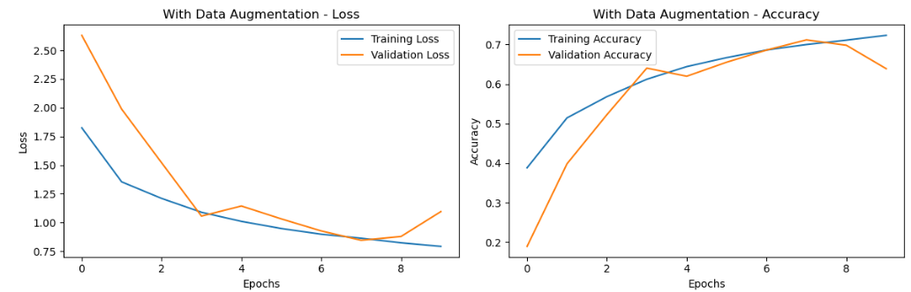
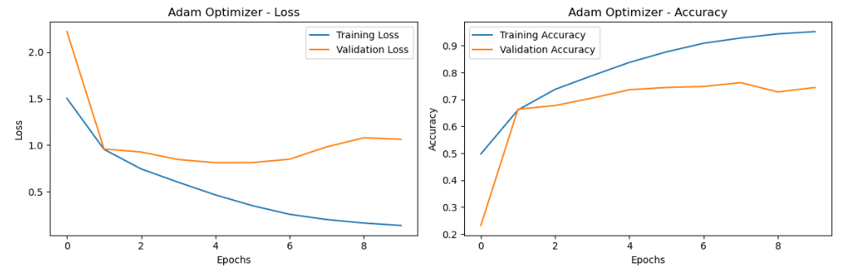
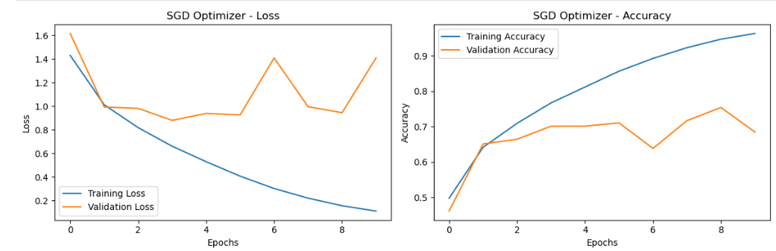
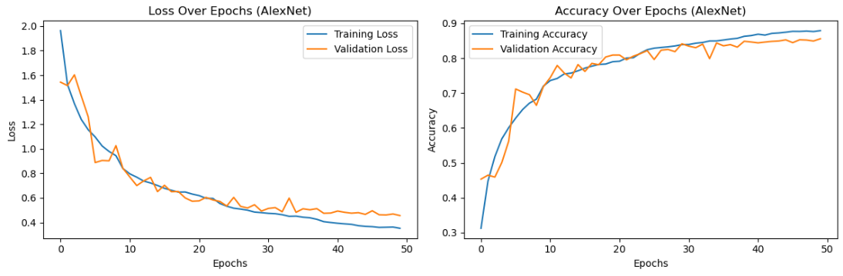
To improve VGG16’s poor initial performance, several architectural and training modifications were applied. These included changes to convolutional filter sizes, the use of data augmentation, and the introduction of a dynamic learning rate schedule. As a result, performance improved markedly, with accuracy increasing to 0.8787 and validation loss dropping to 0.3533. This demonstrates that the effectiveness of AlexNet-style architectures is highly dependent on task-specific tuning. The improved results and modified architecture are shown in “Fig. 15b”.

Optimization Techniques on CNNNet (CIFAR-10)

Batch Normalization
Adding batch normalization improved accuracy from 0.9168 to 0.9544, though it extended training time from 10.6 to 18.4 minutes. Validation loss increased to 1.1422, suggesting potential overfitting despite improved performance. “Fig. 16” demonstrates the trade-offs of using batch normalization.

Activation Functions
Performance varied across activation functions:
ReLU: 0.9581 accuracy, validation loss 1.2636
Sigmoid: Highest accuracy (0.9765) and lowest loss (0.0861)
The Tanh: 0.8949 accuracy
Leaky ReLU: 0.9361 accuracy, but higher validation loss (1.6162)
“Fig. 17-21” compare CNNNet with different activation functions.

Data Augmentation
Unexpectedly, data augmentation reduced accuracy from 0.9546 to 0.7215, and validation accuracy dropped from 0.7511 to 0.6387. This indicates a poor compatibility between augmentation strategies and the dataset/model setup.
“Fig. 22” and “Fig. 23” illustrate the effects of data augmentation.

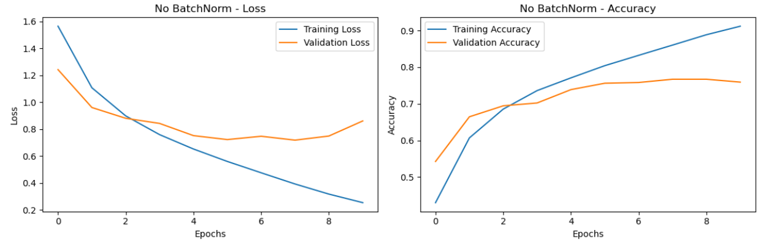
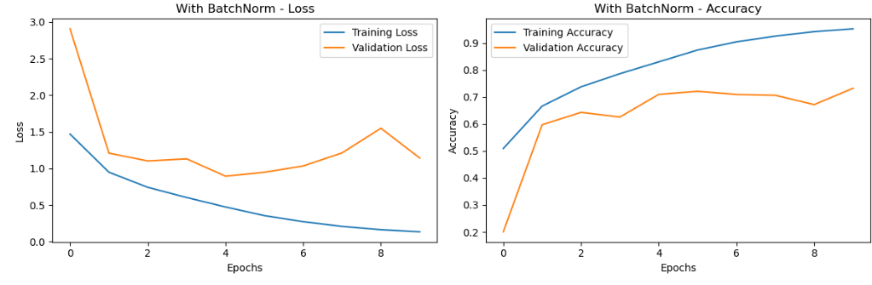
Optimizer Comparisons

Adam:
0.9580 accuracy, validation loss 1.0639

SGD:
Slightly higher accuracy (0.9651), but worse validation loss (1.4098), indicating less stable generalization
“Fig. 24” and “Fig 25” highlight accuracy vs. stability trade-offs for optimizers.

Findings Summary
Distributed training showed limited benefits for simpler models or datasets but significantly improved performance for deep networks like ResNet-50.
AlexNet underperformed on CIFAR-10 without modifications, but architectural and hyperparameter tuning led to a substantial improvement.
Optimization strategies, batch normalization, activation function tuning, and optimizer choice, had a noticeable impact on both accuracy and training stability.
Data augmentation produced mixed results, emphasizing the need for dataset-specific tuning rather than blanket application.

Areas for Further Investigation
Explore alternative distributed training strategies beyond DataParallel and MirroredStrategy, such as Horovod (Sergeev and Balso, 2018) and the Parameter Server Strategy (Li et al., 2014; Ho et al., 2013), which are designed for more scalable and efficient distributed deep learning in multi-node environments.
Test additional optimizers, particularly adaptive strategies, to further explore the balance between training accuracy and generalization.

Limitations
While this study provides a detailed analysis of CNN performance under varying architectures and training environments, several limitations affected the scope and interpretation of the results:

Hardware Constraints
All training was conducted on single-node machines with limited access to GPU resources. Although distributed training was implemented in code using DataParallel (PyTorch) and MirroredStrategy (TensorFlow), the experiments did not run on actual multi-GPU or multi-node clusters. As a result, the full performance potential of distributed training could not be measured. The setups used in this study served more as structural simulations than as high throughput distributed environments.

Dataset Scale
Fashion MNIST and CIFAR-10 were selected for their accessibility and suitability within constrained hardware environments. However, neither dataset constitutes true "big data" in scale or complexity. While CIFAR-10 introduces RGB data and more variability, results may not generalize to enterprise-level or production-scale datasets such as ImageNet or Open Images.

Framework and Environment Differences
Comparisons between PyTorch and TensorFlow were influenced by differing system environments (e.g., virtual machine vs. local Windows system with more RAM). While TensorFlow consistently demonstrated faster training times, these differences may reflect hardware advantages, not purely framework-level performance.

Distribution Strategy Scope
Only two distribution strategies, DataParallel and MirroredStrategy, were implemented. Other advanced methods such as Horovod (Sergeev and Balso, 2018) or Parameter Server architectures (Li et al., 2014; Ho et al., 2013) were not explored. These could yield different results, particularly in true multi-node environments.

Generalization and Overfitting
Although validation losses were monitored, the study did not perform cross-validation or test generalization on external datasets. In some cases (e.g., batch normalization), models showed signs of overfitting, suggesting that further regularization or evaluation on unseen data may be necessary to assess robustness.

Future Work
This study lays a foundation for further exploration into scalable deep learning within big data environments. Several avenues could build on this work to provide deeper insights and greater applicability:

True Multi-GPU and Multi-Node Training
Future experiments should be conducted in genuine distributed environments, such as cloud-based clusters or high-performance computing setups, where multiple GPUs or nodes are available. This would allow full testing of distributed training strategies and offer a more accurate assessment of performance scaling, especially for deeper architectures like ResNet50.

Larger and More Complex Datasets
To fully evaluate CNN performance in big data contexts, future studies should employ larger datasets, such as ImageNet, Open Images, or domain-specific data lakes. These would better test the capacity of distribution strategies and model scalability, particularly when combined with high-resolution input data and greater class diversity.

Advanced Distribution Strategies
While this study used DataParallel and MirroredStrategy, future research could explore more advanced training strategies such as:
Horovod (Sergeev and Balso, 2018), for efficient gradient averaging across multiple GPU.
Parameter Server strategies (Li et al., 2014; Ho et al., 2013), for flexible coordination between worker and server nodes in large-scale training.
And emerging tools such as TFDTensor or distributed training with Apache Spark (Moritz et al., 2016).
These could be benchmarked not only for speed and accuracy but also for ease of implementation and scalability.

Real-Time and Streaming Data Applications
Expanding this research to include real-time or streaming data scenarios could better reflect modern big data workflows. CNNs deployed on streaming image data (e.g., satellite, video, or sensor feeds) would require architectural adaptation and possibly integration with data pipelines using Apache Kafka or Spark Streaming (Lunga et. Al, 2020, Chen et. al 2021).

Broader Optimization Exploration
Further research should also examine:
More adaptive optimizers (e.g., AdaBound, RAdam).
Automated hyperparameter tuning (e.g., using Optuna or Ray Tune).
And the combination of regularization strategies (dropout, early stopping, L2 penalties) to manage overfitting when working with larger models and datasets.

Cross-Framework Performance Comparisons
While TensorFlow showed stronger performance in this study, future research could benchmark other frameworks (e.g., JAX, MXNet, or FastAI) across identical tasks and hardware to determine which offers the best trade-off between speed, flexibility, and ease of use.

Conclusion
This research investigated the performance of Convolutional Neural Networks (CNNs) in the context of image recognition tasks, with a particular focus on the impact of model complexity, training environment (single node vs. distributed), and optimization strategies. Using Fashion MNIST and CIFAR-10 as test datasets, the study compared baseline and advanced CNN architectures, including a modular CNN, an AlexNet-style model, and ResNet50, across both PyTorch and TensorFlow frameworks.
Although true multi-GPU environments were not available, distributed training strategies were implemented to simulate scalable deep learning structures. The results showed that for simpler models and datasets, such as CNNNet on Fashion MNIST, distributed training did not yield meaningful improvements. However, more complex architectures like ResNet50 significantly benefited from distribution, achieving higher accuracy and lower validation loss in simulated parallel environments.
The study also revealed the considerable influence of optimization techniques, such as batch normalization, activation function selection, and optimizer choice, on model performance. In particular, adaptive optimizers and tuning of activation functions led to notable accuracy gains, while data augmentation produced mixed results.
Overall, this research highlights the importance of aligning network design, training environment, and optimization strategies with the complexity of the task. It further demonstrates that even under hardware constraints, meaningful experimentation can be conducted to explore the structures and performance implications of scalable CNNs in big data contexts.
.

References

Abadi, M. et al. (2016) ‘TensorFlow: Large-Scale Machine Learning on Heterogeneous Distributed Systems’, arXiv preprint. Available at: https://doi.org/10.48550/arXiv.1603.04467.
Abadi, M. et al. (no date) ‘TensorFlow: A System for Large-Scale Machine Learning’. [Preprint].
Chen, L. et al. (2021) ‘Review of image classification algorithms based on convolutional neural networks’, Remote Sensing, 13(22), p. 4712. Available at: https://doi.org/10.3390/rs13224712.
Dean, J. et al. (2008) ‘MapReduce: simplified data processing on large clusters’, Communications of the ACM, 51(1), pp. 107–113. Available at: https://doi.org/10.1145/1327452.1327492.
Dean, J. et al. (2012) ‘Large scale distributed deep networks’, in Advances in Neural Information Processing Systems. Curran Associates, Inc. Available at: https://papers.nips.cc/paper_files/paper/2012/hash/6aca97005c68f1206823815f66102863-Abstract.html (Accessed: 9 March 2025).
Deng, J. et al. (no date) ‘ImageNet: A large-scale hierarchical image database’. [Conference paper].
He, K. et al. (2016) ‘Deep residual learning for image recognition’, in 2016 IEEE Conference on Computer Vision and Pattern Recognition (CVPR). Las Vegas, NV, USA: IEEE, pp. 770–778. Available at: https://doi.org/10.1109/CVPR.2016.90.
Ioffe, S. and Szegedy, C. (2015) ‘Batch normalization: Accelerating deep network training by reducing internal covariate shift’, in Proceedings of the 32nd International Conference on Machine Learning (ICML). Lille, France: JMLR.org, pp. 448–456.
Kingma, D.P. and Ba, J. (2017) ‘Adam: A method for stochastic optimization’, arXiv preprint arXiv:1412.6980. Available at: https://doi.org/10.48550/arXiv.1412.6980.
Koulali, R., Zaidani, H. and Zaim, M. (2021) ‘Image classification approach using machine learning and an industrial Hadoop-based data pipeline’, Big Data Research, 24, p. 100184. Available at: https://doi.org/10.1016/j.bdr.2021.100184.
Krizhevsky, A., Sutskever, I. and Hinton, G.E. (2017) ‘ImageNet classification with deep convolutional neural networks’, Communications of the ACM, 60(6), pp. 84–90. Available at: https://doi.org/10.1145/3065386.
Li, M. (2014) ‘Scaling distributed machine learning with the parameter server’, in Proceedings of the 2014 International Conference on Big Data Science and Computing. Beijing, China: ACM, p. 1. Available at: https://doi.org/10.1145/2640087.2644155.
Luo, W., Li, Y., Urtasun, R. and Zemel, R. (2017) ‘Understanding the effective receptive field in deep convolutional neural networks’, arXiv preprint arXiv:1701.04128. Available at: https://arxiv.org/abs/1701.04128.
Lunga, D. et al. (2020) ‘Apache Spark accelerated deep learning inference for large scale satellite image analytics’, IEEE Journal of Selected Topics in Applied Earth Observations and Remote Sensing, 13, pp. 271–283. Available at: https://doi.org/10.1109/JSTARS.2019.2959707.
Macêdo, S. (2020) samuelmacedo83/tf.distributed. GitHub. Available at: https://github.com/samuelmacedo83/tf.distributed (Accessed: 23 March 2025).
Mahmud, M.S. et al. (2020) ‘A survey of data partitioning and sampling methods to support big data analysis’, Big Data Mining and Analytics, 3(2), pp. 85–101. Available at: https://doi.org/10.26599/BDMA.2019.9020015.
Moritz, P. et al. (2016) ‘SparkNet: Training deep networks in Spark’, arXiv preprint arXiv:1511.06051. Available at: https://doi.org/10.48550/arXiv.1511.06051.
Nadachowski, P. et al. (2024) ‘Classification of glacial and fluvioglacial landforms by convolutional neural networks using a digital elevation model’, IEEE Journal of Selected Topics in Applied Earth Observations and Remote Sensing, PP, pp. 1–17. Available at: https://doi.org/10.1109/JSTARS.2024.3470253.
Najafabadi, M.M. et al. (2015) ‘Deep learning applications and challenges in big data analytics’, Journal of Big Data, 2(1), p. 1. Available at: https://doi.org/10.1186/s40537-014-0007-7.
Pang, B., Nijkamp, E. and Wu, Y.N. (2020) ‘Deep learning with TensorFlow: A review’, Journal of Educational and Behavioral Statistics, 45(2), pp. 227–248. Available at: https://doi.org/10.3102/1076998619872761.
Sergeev, A. and Balso, M.D. (2018) ‘Horovod: Fast and easy distributed deep learning in TensorFlow’, arXiv preprint arXiv:1802.05799. Available at: https://doi.org/10.48550/arXiv.1802.05799.
Sharma, N., Jain, V. and Mishra, A. (2018) ‘An analysis of convolutional neural networks for image classification’, Procedia Computer Science, 132, pp. 377–384. Available at: https://doi.org/10.1016/j.procs.2018.05.198.
Sharma, V. et al. (2024) ‘Detecting plant diseases at scale: A distributed CNN approach with PySpark and Hadoop’, Procedia Computer Science, 235, pp. 1044–1057. Available at: https://doi.org/10.1016/j.procs.2024.04.099.
Shvachko, K. et al. (2010) ‘The Hadoop distributed file system’, in Proceedings of the 2010 IEEE 26th Symposium on Mass Storage Systems and Technologies (MSST), pp. 1–10. Available at: https://doi.org/10.1109/msst.2010.5496972.
Xiao, H., Rasul, K. and Vollgraf, R. (2017) ‘Fashion-MNIST: A novel image dataset for benchmarking machine learning algorithms’, arXiv preprint arXiv:1708.07747. Available at: https://doi.org/10.48550/arXiv.1708.07747.

